Maze Solver Project Manual

Youssef Mohamed, Ahmed Hossam, Mina Samir, Mohamed Magdy, Mohab Asharaf

211777 213581 212257 213059 210439

Faculty of Computer Science

Group A

Dr. Ammar Wael

November 11, 2022

**How To Run**

Step 1: Navigate to the Executable File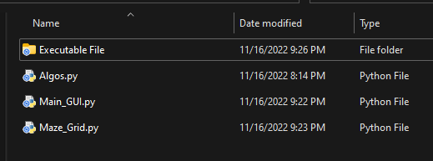

Step 2: Launch MazeSolver.exe

Step 3: Choose the algorithm you want to apply

Step 4: After choosing the desired algorithm, you will be taken to the grid where you will set the start position by left clicking your mouse ONCE on any node.

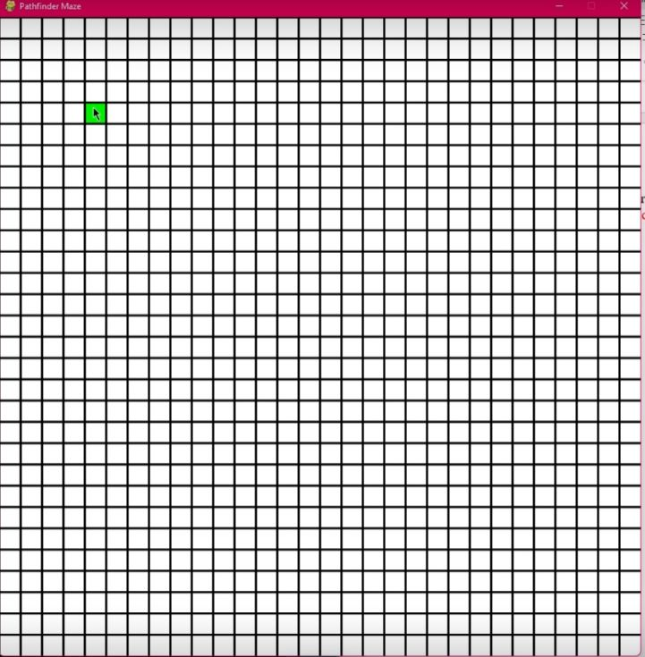

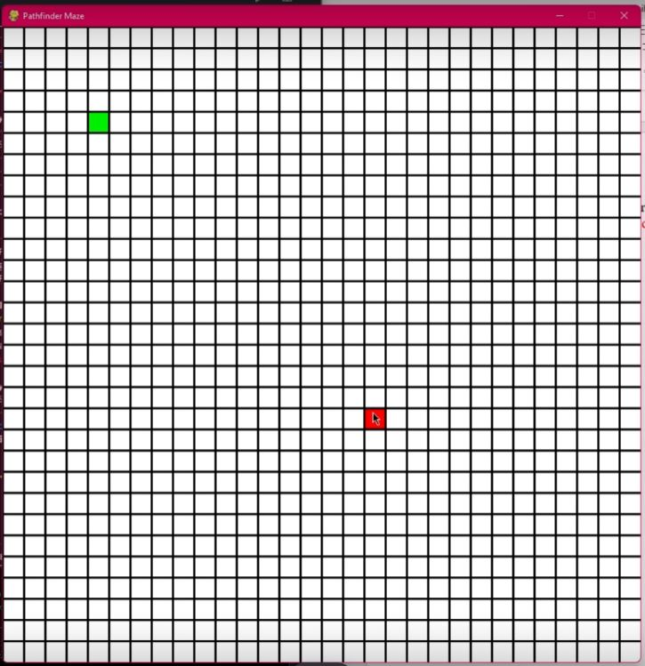Step 4: After adding the start position, you will again press the left mouse button ONCE to add the red End node.

Step 5: Add the walls by pressing and dragging the left mouse button across the grid nodes.

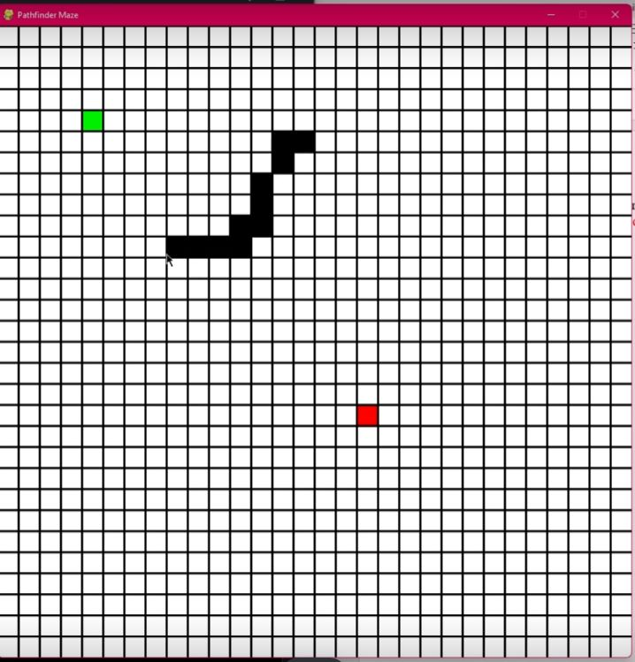

Step 6: Now press Enter to apply the previously chosen algorithm

If there was no path result found a “No path” prompt will take you back to the original screen.

Note: If you want to reset the canvas press R on your keyboard.